**EEE4113F**

**Design Report – Housing Subsection**

**Liam Breytenbach**

**BRYLIA002**

**Introduction**

The purpose of the mechanical housing is to protect the electrical components from the harsh elements that surround it. This includes dust and rain which could damage and corrode the electrical components over time. The enclosure must be easy for the user to set-up and use as well as be versatile enough to adapt to most environments it could potentially encounter. The design of the mechanical enclosure went through several iterations and diverged into two main ideas. Each of the ideas have figures of merit to consider. Changes throughout the design iterations were prompted by factors such as material, ease of assembly, versatility and airflow.

**User Requirements**

|  |  |
| --- | --- |
| Label | Requirements |
| HR-1 | The product must be easy to transport |
| HR-2 | The housing must not break in the Kalahari |
| HR-3 | The product must be user friendly |
| HR-4 | The housing must not disturb the wildlife around it |
| HR-5 | The product must be cheap |

**Functional Requirements**

|  |  |
| --- | --- |
| Label | Functional Requirements |
| HFR-1 | All of the components must be able to fit into the housing as a single unit |
| HFR-2 | The housing must be dust proof and water-resistant |
| HFR-3 | Unit must easily rotate and translate about the x, y, z axes |
| HFR-4 | The product must be coated in an environmentally appropriate material |
| HFR-5 | The product must be within budget. |

**Design Specifications**

|  |  |
| --- | --- |
| Label | Specifications |
| HS-1 | The housing unit must be 175mm x 100mm x 40mm |
| HS-2 | Unit must have 6 degrees of Freedom |
| HS-3 | The solar panel unit must be 375mm x 250mm x 500mm |
| HS-4 | The product must be made of plastic or wood and coated sufficiently. |
| HS-5 | The housing must be < R280 |

**Methodology and Design Choices**

**Dimensions**

The design of the housing must accommodate all the components from the Power, Microcontroller and Sensor Submodules. Placement of these components also must be considered.

**User Friendly**

The design is made to be as user friendly as possible. This is done in a number of ways.

**Ease of Setup**

The housing is mounted with two ball and socket joints. This allows the user to set up the camera very quickly and effectively. The housing is also equipped with 2 water-levels that allow the user to set up the camera perfectly level or aligned with a particular axis.

The bottom of the ball and socket joint is attached to three flexible plates. These plates allow the housing to be attached to a surface with any angle, whether flat or curved. Since the housing is mounted in a tree, screws are used to attach the plates to the trunk, securing the housing for as long as is intended.

**Ease of Use**

The housing of the Camera, Sensor and Power Modules is sealed with a retractable lid. This lid is transparent as the design of the PCB allows for the user to observe the battery level indicator and determine whether certain components on the PCB and Camera are functioning as expected. The lid can be easily removed and acts as a solid barrier to the climate surrounding it. As mentioned above, the housing of the camera can be easily adjusted to any desired angle due to the ball and socket joints.

**Thermal Considerations**

Thermal regulation is a crucial factor when considering the design of the housing. Thermal Regulation falls into two categories.

**Active:**

This method involves using electricity to lower the temperature of the system. This includes air conditioning systems, fans, or liquid cooling systems. These systems actively remove heat from the device to maintain a desired temperature.

**Passive:**

This method relies on natural processes or materials to dissipate heat without the need for electricity. This includes strategic design features to maximize natural airflow, insulation to reduce heat transfer, or using materials with high thermal mass to absorb and release heat slowly

The environment surrounding the mechanical housing ranges from 10-45 degrees. Thermal considerations must be made to accommodate each of the components within the housing. Due to the system attempting to conserve as much power as possible, a passive thermal regulation system is used. Components cannot be stacked on top of one another as this can lead to overheating of the components. There must be adequate airflow through the housing, such that the heatsinks on certain devices are able to function properly.

**Cost**

The cost of 3D printing is relatively low. Fairly complex designs can be made, which cater for specific needs of the housing subsection. A customized housing can be made using a 3D designer tool (Such as Solidworks) where the user is in complete control of the design. Another viable option is using a wooden frame to house the components. Wood is a very strong substance that is readily available. It is relatively cheap and can be cut, glued and painted to meet the design requirements. A large portion of the housing subsection is 3D printed. Although the strength of a 3D print is sometimes unreliable, the requirements do not need the housing to be unbreakable. Majority of the time, the housing will not be touched or moved. For these reasons, a 3D print using 0.15mm thickness PLA is sufficient for the task. The solar panel is mounted to a wooden structure. The original design consisted of a 3D printed design, however, the size and weight of the solar panel is too large for a 3D print to be successful.

**Environmental Considerations**

It is important when observing wildlife not to disturb their natural behaviours such as mating, feeding and migratory patterns. This is considered in the design of the housing. The housing is coated to resemble the natural environment around it. It is not too large as to disturb wildlife and the housing itself blends into the bark, leaves and features surrounding it. The hardware supporting the Solar Panel is made of pine wood. Although this is an alien species of flora, pine is not harmful to the species that surround it. Overall the housing takes the wildlife around it into consideration as to not disturb it in any dramatic way.

**Design Choices**

**Housing Design 1**

This design aims to reduce the cost and design time to observe Fork Tailed Drongos. It is a simple design, that sufficiently houses the electrical components and meets most of the design specifications.

Pros:

* Low Cost.
* Short Design time.
* Relatively small and compact.

Cons:

* Is not user friendly (difficult to set up).
* Can lead to the electrical components overheating.
* Hard to adjust.

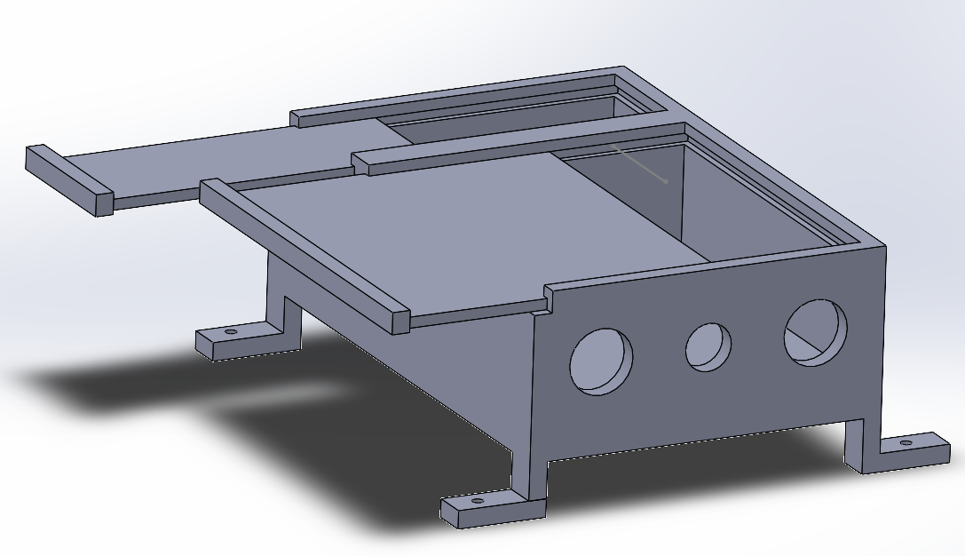

This design attempts to reduce the size of the mechanical housing. It involves stacking the PCB, Rasbery Pi and Sensor (Separated by insulation). While this design is an elegant solution. The major drawback is overheating of the components as well as visibility of the PCB. The PCB has battery level indicators as well as other indicator LEDs that need to be visible to the user. If the user were to try view the PCB, they would have to dismantle the housing structure to do so.

**Housing Design 2**

This design is still relatively low cost and is aimed to make the product as user friendly as possible. It incorporates aspects from Design 1, however has an added ball and socket joint that allows the user to position the camera at any angle they desire. Additionally the design is more spread out, allowing the user to view the PCB through the transparent lid present on the top of the housing.

Pros:

* Low Cost.
* User Friendly.
* Can easily be adjusted.

Cons:

* Longer 3D print time.
* Slightly Larger.

This design meets all of the design requirements. The components within the enclosure are spread out to reduce overheating. The housing can be easily adjusted to get any angle the user desires. While it is slightly larger than Housing Design 1, it is marginal. Overall Housing Design 2 is a better fit for the design of the enclosure.

**Solar Panel Casing Design 1**

This design is used to hold the solar panel in place. This is a tricky concept as the solar panel is not attached to the main housing. The main housing will be placed on and around the trunk of a tree. Unfortunately, this means that very little sunlight will reach it. For this reason, the placement of the solar panel needs to be sufficiently far away such that the sunlight is not blocked by the canopy of the tree.

Pros:

* Low Cost.
* Strong

Cons:

* Too large for 3D printing
* Cannot be adjusted easily

This design takes into consideration the weight and size of the solar panel. It also considers that the solar panel cannot be attached to the tree itself.

**Solar Panel Casing Design 2**

This design is also used to hold the solar panel in place. Due to very little sunlight being able to reach it when attached to the tree, the placement of the solar panel must be at a distance from the trunk.

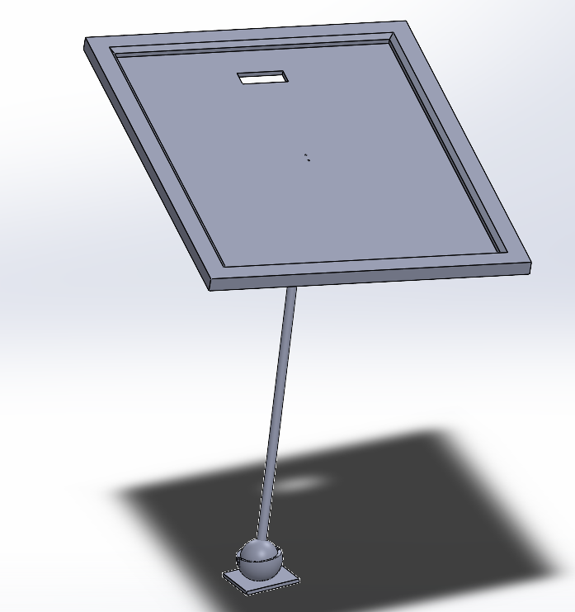

This is a very elegant design that attempts to make the use of the solar panel more user friendly. Unfortunately due to the weight of the solar panel, this design cannot be used as the frictional forces acting on the ball and socket joints overcome it’s ability to maintain a fixed orientation. For this reason, Solar Panel Casing Design 1 is used as it is strong enough to hold the solar panel in place at a sufficient distance from the tree.

**Final Design**

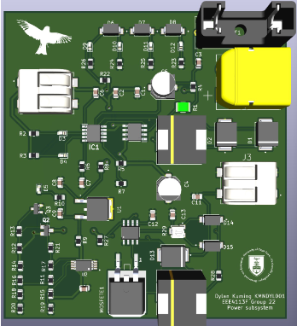

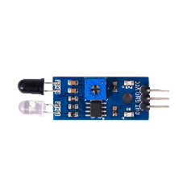

**16cm**

**17.5cm**

**90cm**

**100cmm**

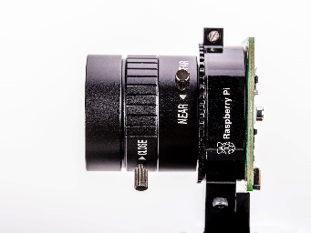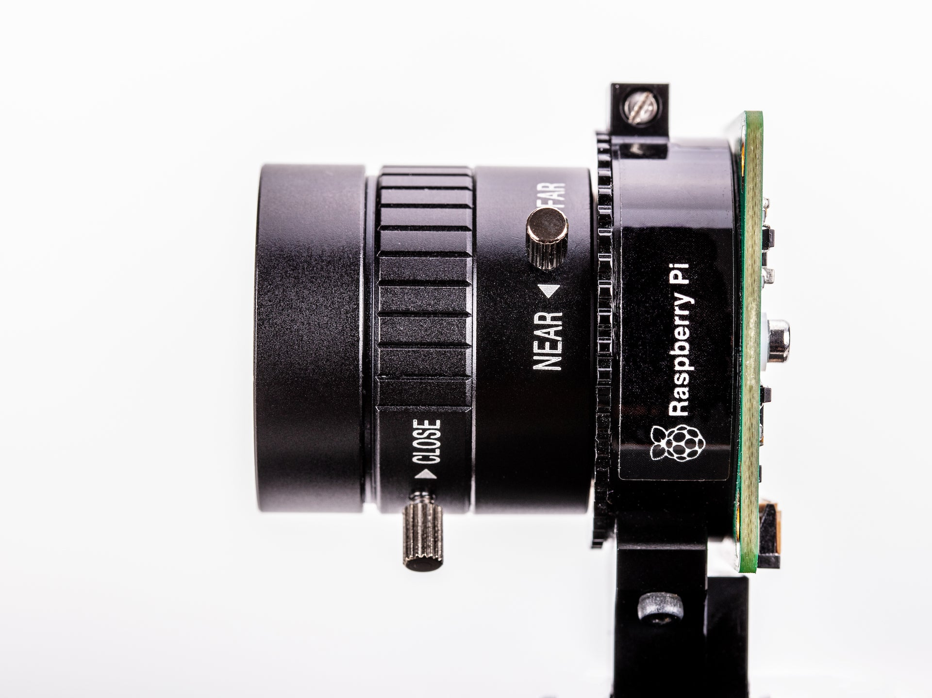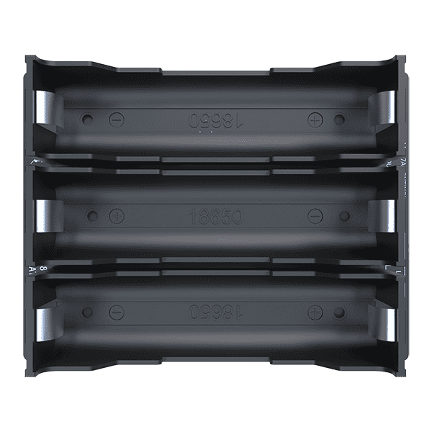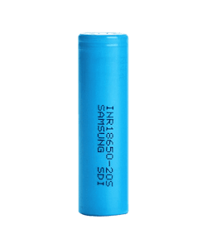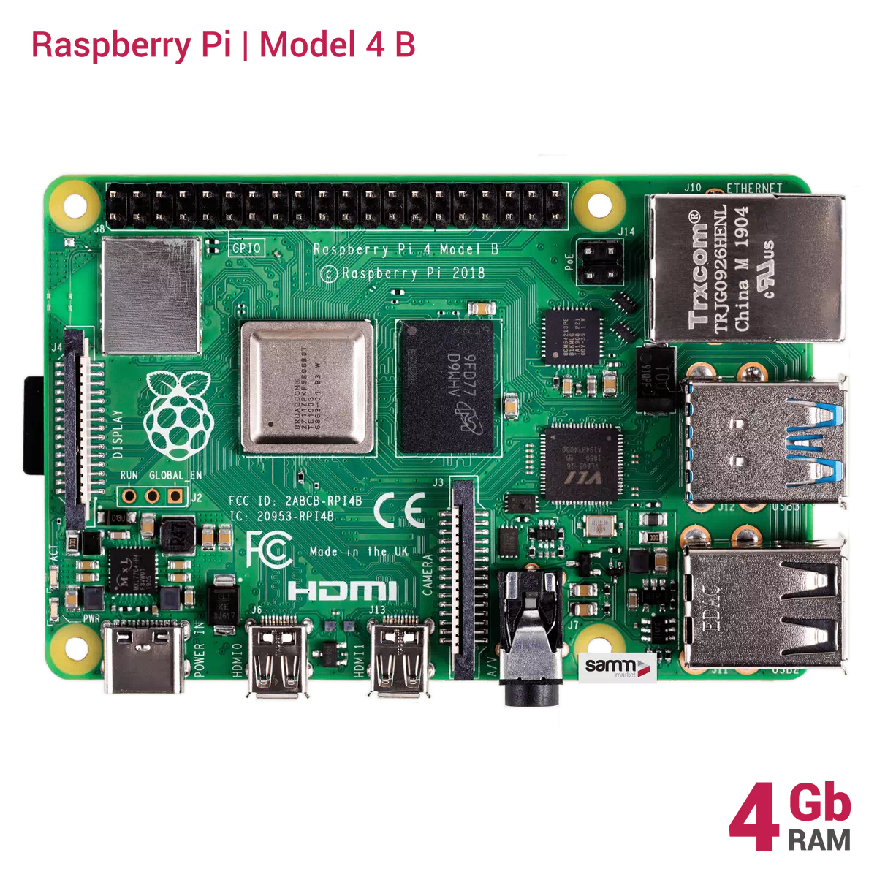

As can be seen from the figure above, the housing has been designed slightly larger than is needed to fit the components within. This is to allow easy access to certain components such as the battery, as well as to allow for component replacement if necessary. On the PCB, there are various indicators such as LEDs and battery level indicators. This design allows for the user to observe within the box without dismantling the entire housing.

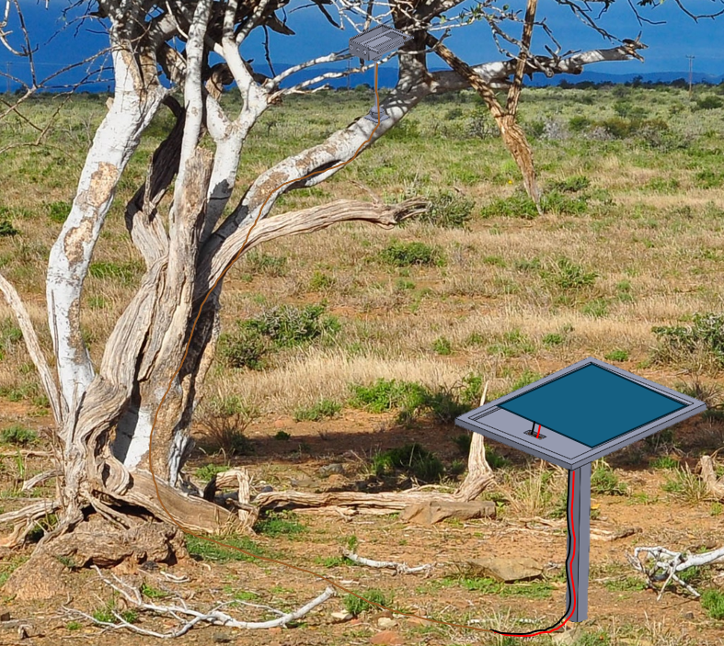

This is the final setup in a simulated environment. Note that the cable running from the Solar Panel to the housing has been disguised as the Fork Tailed Drongo does interprets cables as a snake and can disturb them from their natural behaviour.

**Testing and Results**

To test the housing subsection, the Functional Requirements and Specifications must be tested.

|  |  |  |  |  |
| --- | --- | --- | --- | --- |
| Label | Refines | Description | Result | Remarks |
| ATP-1 | HFR-1, HS-1 | Place all components inside the housing. | Passed | All components can fit into the housing. |
| ATP-2 | HFR-1, HS-3 | Place the Solar Panel on the Solar Panel Casing | Passed | The solar panel fits securely onto the Solar Panel Casing. |
| ATP-3 | HFR-2 | Pour 250g of sand on the housing | Passed | The housing does not allow sand to get inside the housing. |
| ATP-4 | HFR-3, HS-2 | Rotate the housing about the x, y, z axes | Passed | The housing can rotate about the x, y and z axes. |
| ATP-5 | HFR-3, HS-2 | Translate the housing in the x, y and z directions | Passed | The housing can move in the x, y and z direction. |

**Acceptance Test Procedures**

**Conclusion**

The housing subsection

% ----------------------------------------------------

% Housing BRYLIA002

% ----------------------------------------------------

\documentclass[class=report,11pt,crop=false]{standalone}

\usepackage{colortbl}

\usepackage{tabularx}

\usepackage{booktabs}

\usepackage{multirow}

\usepackage{changepage}

\input{Style/ChapterStyle.tex}

\input{FrontMatter/Glossary.tex}

\definecolor{Gray}{gray}{0.9}

\begin{document}

% ----------------------------------------------------

\chapter{Mechanical Housing Subsystem}

\vspace{0.5cm}

% ----------------------------------------------------

This section was completed by Liam Breytenbach, BRYLIA002.

\section{Mechanical Housing Introduction}

The purpose of the mechanical housing is to protect the electrical components from the harsh elements that surround it. This includes dust and rain which could damage and corrode the electrical components over time. The enclosure must be easy for the user to set-up and use as well as be versatile enough to adapt to most environments it could potentially encounter. The design of the mechanical enclosure went through several iterations and diverged into two main ideas. Each of the ideas have figures of merit to consider. Changes throughout the design iterations were prompted by factors such as material, ease of assembly, versatility and airflow.

%------------------------------------------------------%

\section{User Requirements}

The Mechanical Housing is designed to enclose and secure the electrical components of the other subsystems and bring them together as a single product:

\begin{table}[h]

\centering

\caption{Mechanical Housing User Requirements}

\label{tab:Mechanical Housing User Requirements}

\begin{tabular}{|c|p{0.5\textwidth}|}

\hline

\textbf{Label} & \textbf{Requirements} \\

\hline

HR-1 & The product must be easy to transport \\

HR-2 & The housing must not break in the Kalahari \\

HR-3 & The product must be user friendly \\

HR-4 & The housing must not disturb the wildlife around it \\

HR-5 & The product must be cheap \\

\hline

\end{tabular}

\end{table}

%------------------------------------------------------%

\section{Functional Requirements}

The Functional requirements outline the key functionalities of the Mechanical Housing outlined in \ref{tab:Mechanical Housing User Requirements}.

\begin{table}[h]

\centering

\caption{Functional Requirements}

\label{tab:functional_requirements}

\begin{tabular}{|c|p{0.5\textwidth}|}

\hline

\textbf{Label} & \textbf{Functional Requirements} \\

\hline

HFR-1 & All of the components must be able to fit into the housing as a single unit \\

HFR-2 & The housing must be dust proof \\

HFR-3 & Unit must have 6 degrees of Freedom \\

HFR-4 & The product must be coated in an environmentally appropriate material \\

HFR-5 & The product must be within budget \\

\hline

\end{tabular}

\end{table}

%------------------------------------------------------%

\section{Design Specifications}

The Design Specifications of the Mechanical Housing will detail how the Housing will meet the Functional and User Requirements.

\begin{table}[h]

\centering

\caption{Specifications}

\label{tab:specifications}

\begin{tabular}{|c|p{0.5\textwidth}|}

\hline

\textbf{Label} & \textbf{Specifications} \\

\hline

HS-1 & The housing unit must be 175mm x 100mm x 40mm \\

HS-2 & Unit must easily rotate and translate about the x, y, z axes \\

HS-3 & The solar panel unit must be 375mm x 250mm x 500mm \\

HS-4 & The product must be made of plastic or wood and coated sufficiently \\

HS-5 & The housing must be less than R280 \\

\hline

\end{tabular}

\end{table}

%------------------------------------------------------%

\section{Methodology and Design Choices}

\subsection{Dimensions}

The design of the housing must accommodate all the components from the Power, Microcontroller, and Sensor Submodules. Placement of these components also must be considered.

\subsection{User Convenience}

The design is made to be as user friendly as possible. This is done in a number of ways.

\subsubsection{Ease of Setup}

The housing is mounted with two ball and socket joints. This allows the user to set up the camera very quickly and effectively. The housing is also equipped with 2 water-levels that allow the user to set up the camera perfectly level or aligned with a particular axis.

The bottom of the ball and socket joint is attached to three flexible plates. These plates allow the housing to be attached to a surface with any angle, whether flat or curved. Since the housing is mounted in a tree, screws are used to attach the plates to the trunk, securing the housing for as long as is intended.

\subsubsection{Ease of Use}

The housing of the Camera, Sensor, and Power Modules is sealed with a retractable lid. This lid is transparent as the design of the PCB allows for the user to observe the battery level indicator and determine whether certain components on the PCB and Camera are functioning as expected. The lid can be easily removed and acts as a solid barrier to the climate surrounding it. As mentioned above, the housing of the camera can be easily adjusted to any desired angle due to the ball and socket joints.

\subsection{Thermal Considerations}

Thermal regulation is a crucial factor when considering the design of the housing. Thermal Regulation falls into two categories.

\subsubsection*{Active:}

This method involves using electricity to lower the temperature of the system. This includes air conditioning systems, fans, or liquid cooling systems. These systems actively remove heat from the device to maintain a desired temperature.

\subsubsection*{Passive:}

This method relies on natural processes or materials to dissipate heat without the need for electricity. This includes strategic design features to maximize natural airflow, insulation to reduce heat transfer, or using materials with high thermal mass to absorb and release heat slowly.

The environment surrounding the mechanical housing ranges from 10-45 degrees. Thermal considerations must be made to accommodate each of the components within the housing. Due to the system attempting to conserve as much power as possible, a passive thermal regulation system is used. Components cannot be stacked on top of one another as this can lead to overheating of the components. There must be adequate airflow through the housing, such that the heatsinks on certain devices are able to function properly.

\subsection{Cost}

The cost of 3D printing is relatively low. Fairly complex designs can be made, which cater for specific needs of the housing subsection. A customized housing can be made using a 3D designer tool (Such as Solidworks) where the user is in complete control of the design. Another viable option is using a wooden frame to house the components. Wood is a very strong substance that is readily available. It is relatively cheap and can be cut, glued and painted to meet the design requirements. A large portion of the housing subsection is 3D printed. Although the strength of a 3D print is sometimes unreliable, the requirements do not need the housing to be unbreakable. Majority of the time, the housing will not be touched or moved. For these reasons, a 3D print using 0.15mm thickness PLA is sufficient for the task. The solar panel is mounted to a wooden structure. The original design consisted of a 3D printed design, however, the size and weight of the solar panel is too large for a 3D print to be successful.

\subsection{Environmental Considerations}

It is important when observing wildlife not to disturb their natural behaviours such as mating, feeding and migratory patterns. This is considered in the design of the housing. The housing is coated to resemble the natural environment around it. It is not too large as to disturb wildlife and the housing itself blends into the bark, leaves and features surrounding it. The hardware supporting the Solar Panel is made of pine wood. Although this is an alien species of flora, pine is not harmful to the species that surround it. Overall the housing takes the wildlife around it into consideration as to not disturb it in any dramatic way.

\subsection{Design Choices}

\subsubsection{Housing Design 1}

This design aims to reduce the cost and design time to observe Fork Tailed Drongos. It is a simple design that sufficiently houses the electrical components and meets most of the design specifications.

\textbf{Pros:}

\begin{itemize}

\item Low Cost.

\item Short Design time.

\item Relatively small and compact.

\end{itemize}

\textbf{Cons:}

\begin{itemize}

\item Is not user friendly (difficult to set up).

\item Can lead to the electrical components overheating.

\item Hard to adjust.

\end{itemize}

\begin{figure}[h]

\centering

\includegraphics[width=0.5\linewidth]{Chapters//Subsystems//Housing_images/Housing Design 1.png}

\caption{Housing Design 1}

\label{fig:enter-label}

\end{figure}

This design attempts to reduce the size of the mechanical housing. It involves stacking the PCB, Rasbery Pi and Sensor (Separated by insulation). While this design is an elegant solution. The major drawback is overheating of the components as well as visibility of the PCB. The PCB has battery level indicators as well as other indicator LEDs that need to be visible to the user. If the user were to try view the PCB, they would have to dismantle the housing structure to do so.

\subsubsection{Housing Design 2}

\label{subsubsec:Housing_Design_2}

This design is still relatively low cost and is aimed to make the product as user friendly as possible. It incorporates aspects from Design 1, however has an added ball and socket joint that allows the user to position the camera at any angle they desire. Additionally the design is more spread out, allowing the user to view the PCB through the transparent lid present on the top of the housing.

\textbf{Pros:}

\begin{itemize}

\item Low Cost.

\item User Friendly.

\item Can easily be adjusted.

\end{itemize}

\textbf{Cons:}

\begin{itemize}

\item Longer 3D print time.

\item Slightly Larger.

\end{itemize}

\begin{figure}[h]

\centering

\includegraphics[width=0.5\linewidth]{Chapters//Subsystems//Housing_images/Housing Design 2.png}

\caption{Housing Design 2}

\label{fig:enter-label}

\end{figure}

This design meets all of the design requirements. The components within the enclosure are spread out to reduce overheating. The housing can be easily adjusted to get any angle the user desires. While it is slightly larger than Housing Design 1, it is marginal. Overall Housing Design 2 is a better fit for the design of the enclosure.

\subsubsection{Solar Panel Casing Design 1}

\label{subsubsec:Solar_Panel_Casing_Design_1}

This design is used to hold the solar panel in place. This is a tricky concept as the solar panel is not attached to the main housing. The main housing will be placed on and around the trunk of a tree. Unfortunately, this means that very little sunlight will reach it. For this reason, the placement of the solar panel needs to be sufficiently far away such that the sunlight is not blocked by the canopy of the tree.

\textbf{Pros:}

\begin{itemize}

\item Low Cost.

\item Strong.

\end{itemize}

\textbf{Cons:}

\begin{itemize}

\item Too large for 3D printing.

\item Cannot be adjusted easily.

\end{itemize}

\begin{figure}[h]

\centering

\includegraphics[width=0.5\linewidth]{Chapters//Subsystems//Housing_images/Solar Panel Casing Design 1.png}

\caption{Solar Panel Casing Design 1}

\label{fig:enter-label}

\end{figure}

This design takes into consideration the weight and size of the solar panel. It also considers that the solar panel cannot be attached to the tree itself.

\subsubsection{Solar Panel Casing Design 2}

This design is also used to hold the solar panel in place. Due to very little sunlight being able to reach it when attached to the tree, the placement of the solar panel must be at a distance from the trunk.

\textbf{Pros:}

\begin{itemize}

\item Low Cost.

\item User Friendly.

\end{itemize}

\textbf{Cons:}

\begin{itemize}

\item Very Large 3D print.

\item Is not strong enough to hold the Solar Panel.

\end{itemize}

\begin{figure}[htbp]

\centering

\includegraphics[width=0.5\linewidth]{Chapters//Subsystems//Housing_images/Solar Panel Casing Design 2.png}

\caption{Solar Panel Casing Design 2}

\label{fig:enter-label}

\end{figure}

This is a very elegant design that attempts to make the use of the solar panel more user friendly. Unfortunately due to the weight of the solar panel, this design cannot be used as the frictional forces acting on the ball and socket joints overcome it’s ability to maintain a fixed orientation. For this reason, Solar Panel Casing Design 1 is used as it is strong enough to hold the solar panel in place at a sufficient distance from the tree.

\section{Final Design}

The Final Design of the Mechanical Housing uses the designs from Housing Design 2 [\ref{subsubsec:Housing_Design_2}] and Solar Panel Casing Design 1 [\ref{subsubsec:Solar_Panel_Casing_Design_1}]. A schematic of the internal layout of the placement of electrical components can be seen below.

\begin{figure}[htbp]

\centering

\includegraphics[width=0.5\linewidth]{Chapters//Subsystems//Housing_images/Final Design Internal Schematic.png}

\caption{Final Design Internal Schematic}

\label{fig:enter-label}

\end{figure}

The housing has been designed slightly larger than is needed to fit the components within. This is to allow easy access to certain components such as the battery, as well as to allow for component replacement if necessary. On the PCB, there are various indicators such as LEDs and battery level indicators. This design allows for the user to observe within the box without dismantling the entire housing.

The Mechanical Housing has been placed in a simulated environment below, to show how the product would look when used in a practical situation.

\begin{quote}

\textbf{Note:} Note that the cable running from the Solar Panel to the housing has been disguised as the Fork Tailed Drongo does interprets cables as a snake and can disturb them from their natural behaviour.

\end{quote}

\begin{figure}[htbp]

\centering

\includegraphics[width=0.5\linewidth]{Chapters//Subsystems//Housing_images/Final Design Practical Use.png}

\caption{Final Design in a Simulates Environment}

\label{fig:enter-label}

\end{figure}

\section{Testing and Results}

To test the Mechanical Housing subsection, the Functional Requirements and Specifications must be tested.

\subsection{Acceptance Test Results}

\begin{table}[htbp]

\centering

\caption{Acceptance Test Plan}

\label{tab:acceptance_test_plan}

\begin{tabular}{|c|c|p{3cm}|c|p{3cm}|}

\hline

\textbf{Label} & \textbf{Refines} & \textbf{Description} & \textbf{Result} & \textbf{Remarks} \\

\hline

ATP-1 & HFR-1, HS-1 & Place all components inside the housing. & Passed & All components can fit into the housing. \\

ATP-2 & HFR-1, HS-3 & Place the Solar Panel on the Solar Panel Casing. & Passed & The solar panel fits securely onto the Solar Panel Casing. \\

ATP-3 & HFR-2 & Pour 250g of sand on the housing. & Passed & The housing does not allow sand to get inside the housing. \\

ATP-4 & HFR-3, HS-2 & Rotate the housing about the x, y, z axes. & Passed & The housing can rotate about the x, y, and z axes. \\

ATP-5 & HFR-3, HS-2 & Translate the housing in the x, y, and z directions. & Passed & The housing can move in the x, y, and z directions. \\

\hline

\end{tabular}

\end{table}

As can be seen, all of the User Functional Requirements and Design Specifications have been met. From this, the User Requirements have also been achieved.

\section{Conclusion}

The Mechanical Housing subsystem plays a vital role in protecting and enclosing the electrical components from the environment while providing user friendly functionality. Through a detailed analysis of user requirements, functional requirements, and design specifications, a Mechanical Housing design has been achieved that meets the subsection's objectives.

Through the design process, two primary housing designs were considered. While Housing Design 1 offers simplicity and cost effectiveness, it lacked user friendliness and thermal regulation capabilities compared to Housing Design 2. Ultimately, the incorporation of a ball and socket joint in Housing Design 2 provided enhanced maneuverability, making it the preferred choice for the final design.

Through testing, the Mechanical Housing subsystem successfully met all of the user requirements, functional requirements, and design specifications. The acceptance test results confirm the functionality and reliability of the housing design, allowing the Mechanical Housing Subsection to be integrated into the larger project framework.

% ----------------------------------------------------%

\newpage

% ----------------------------------------------------

\ifstandalone

\bibliography{../Bibliography/References.bib}

\printnoidxglossary[type=\acronymtype,nonumberlist]

\fi

\end{document}

% ----------------------------------------------------

Wood = R50

3D Printing = R100

Paint = R60

Crews + Hinges = R40

Glue = R28

Total = R278

Exploring multiple design ideas allows us to gather insights into their strengths and weaknesses. By considering different perspectives, we can identify the pros and cons of each idea and incorporate them into a refined final design. The collective benefits of multiple ideas while mitigating their individual limitations, allows us to obtain an optimal solution that meets the requirements resulting in a final design that is more robust, efficient, and innovative.